Project Profile Mamiko Ino

\*Time line

2017/06 I started studying computer science, and Java

- One professor recommended me to study programming languages.

↓

2017/10 I participated “Todai Girl’s Hackathon 2017”

- At this hackathon, I, one friend of mine and an engineer made very simple app for Android by using Java and Android Studio. This app can suggest user for wearing some kind of clothes, considering temperature and weather. I took a role of making all function of App with advice from the engineer.

↓

2018/05/07 Test for joining STEP development course of Google

- At this test, I used Python3 as programming language.

↓

2018/05-07 I joined STEP development course of Google

- At this course, I leaned basic computer science and structure of data.

↓

2018/07/09 Interview for working as intern at Google

- At this interview, I used Python3 as programming language

↓

2018/08-09 Internship at Google as STEP intern

\*Description for Project (at Todai Girl’s Hackathon 2017)

　・Content of this project/ Title

Making an android app which can teach user what to wear today. This app can recommend user to wear T-shirts or sweater or something like that by considering temperature, weather, and user’s characteristic, like sensitive to cold/heat.

・Purpose of this project/Goal

Helping people who struggle every morning to wear adequate clothes not to catch a cold and feel uncomfortable.

・Problem solved by this project

Some people can know what to wear by watching a weather forecast, but there is also some people who can’t know what to wear with having some information about weather and temperature and catch a cold…, like me. This app can help such people. If you input today’s weather and temperature, app will teach you what to wear. Some may think “How does it work for people who sensitive to heat/cold?”. Don’t worry. You can set sensitivity to heat/cold at first, and also you can send feedback and app will fit you.

・Most creative/making effort part of this project

That is receiving user’s feedback part. In this app, suggestion will be made by one variable, temperature user feel. This variable will be decided by sensitivity to heat/cold, temperature and weather. By this feedback, sensitivity will be improved every day.

・Diagram related to this project

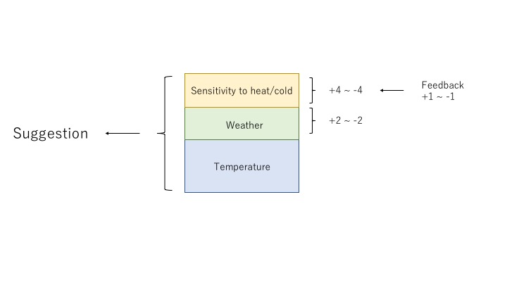

・Some screenshots of app

